AWS Lambda (serverless compute service)

AWS Lambda is a serverless compute service provided by AWS that lets you run your code without managing servers. You simply upload your code, and Lambda automatically runs it whenever an event happens, such as a file upload, an API request, or a scheduled time. AWS takes care of the servers, scaling, and maintenance, so you can focus only on writing your code. You pay only for the time your code runs.

>>What is AWS Lambda?
AWS Lambda is a serverless computing service provided by AWS.
- You write your code.
- Upload it to Lambda.
- AWS runs the code whenever it is triggered.
- You don't need to create or manage an EC2 instance.
Serverless doesn't mean there are no servers.
It means AWS manages the servers for you.

>>Why Do We Use Lambda?
Normally, if you use an EC2 instance:
- Launch EC2
- Install OS updates
- Install software
- Configure security
- Monitor CPU
- Pay even when idle
With Lambda:
- Upload code
- AWS manages everything
- Pay only when your code runs

Event
↓
AWS Lambda
↓
Runs your code
↓
Returns output

>>What is an Event?
An event is something that happens.
Examples:
- File uploaded to S3
- User logs in
- HTTP request from a website
- New row added to DynamoDB
- Message arrives in SQS
- Schedule reaches a specific time
When an event occurs, Lambda starts automatically.

>>Lambda Triggers
A trigger tells Lambda when to run.
Common triggers:
- Amazon S3
- API Gateway
- EventBridge (CloudWatch Events)
- DynamoDB
- SQS
- SNS
- CloudWatch Alarm
- CloudWatch Logs
- AWS IoT
- CodeCommit

>>Languages Supported
You can write Lambda functions in:
- Python
- Node.js
- Java
- C#
- Go
- Ruby
- PowerShell
- Custom Runtime
Python is the easiest for beginners.

>>Lambda Execution Flow
Create Function
↓
Upload Code
↓
Configure Trigger
↓
Event Happens
↓
Lambda Starts
↓
Code Executes
↓
Returns Result
↓
Stops Automatically

>>Lambda Features
1. Serverless
2. Automatic Scaling
3. Pay Per Use
4. High Availability
5. Fast Deploymen
6. Secure

>>Lamdba Examples:
Example 1: Send Email
User submits contact form
↓
API Gateway
↓
Lambda
↓
SNS
↓
Email Sent

Example 2: Daily Backup
Every day at 11 PM
↓
EventBridge
↓
Lambda
↓
Backup Database

Task:
Stop One EC2 Instance Automatically at a Specific Time Using AWS Lambda and EventBridge
Scenario
- You have 1 EC2 instance running.
- You want AWS Lambda to stop that instance automatically.
- AWS EventBridge will trigger the Lambda function at a specific time.
- Region example: us-east-1 (n.virginia)

>>Final Workflow
Running EC2 > EventBridge waits for scheduled time > Triggers Lambda
> Lambda executes Python code > stop_instances > EC2 becomes Stopped

If you mean Python modules commonly used in AWS Lambda, these are the most important ones:
Python Module | Purpose
boto3 | Interact with AWS services (S3, EC2, Lambda, DynamoDB, SNS, SQS, etc.).
json | Read and create JSON data.
os | Access environment variables and file paths.
datetime | Work with dates and times.
time | Add delays or measure execution time.
logging | Write logs to Amazon CloudWatch.
uuid | Generate unique IDs.
base64 | Encode and decode Base64 data.
urllib.request / urllib.parse | Make HTTP requests and work with URLs.
math | Perform mathematical operations.
random | Generate random numbers or values.
re | Search and manipulate text using regular expressions.
csv | Read and write CSV files.
io | Handle in-memory file operations.
sys | Access Python runtime information.
collections | Use advanced data structures like Counter and defaultdict.
Most Common Modules Used in AWS Lambda
- boto3 – Access AWS services.
- json – Process JSON input and output.
- os – Read environment variables.
- logging – Send logs to CloudWatch.
- datetime – Handle date and time.
Example
import boto3
import json
import os
import logging
from datetime import datetime

logger = logging.getLogger()
logger.setLevel(logging.INFO)

def lambda_handler(event, context):
logger.info("Lambda function started")

bucket_name = os.environ.get("BUCKET_NAME", "my-bucket")
current_time = datetime.now().strftime("%Y-%m-%d %H:%M:%S")

return {
"statusCode": 200,
"body": json.dumps({
"message": "Lambda executed successfully",
"bucket": bucket_name,
"time": current_time
})
}

Interview Question
Q: Which Python modules are commonly used in AWS Lambda?
Answer: The most commonly used modules are:
- boto3
- json
- os
- logging
- datetime
- time
- uuid
- base64
- urllib
- csv
These modules help Lambda interact with AWS services, process data, log information, and perform common programming tasks.

Task:
Stop One EC2 Instance Automatically at a Specific Time Using AWS Lambda and EventBridge

Step 1:
Create Lambda Function
Step 2: Give Function name :- Stop Instance
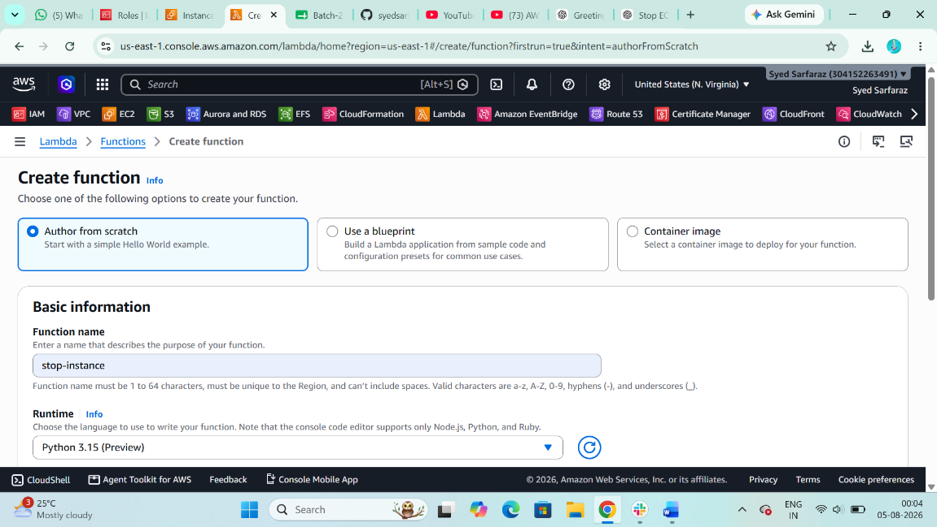

Step 3: Create a New IAM ROLE with EC2 Full Access And Attached with Lambda Function
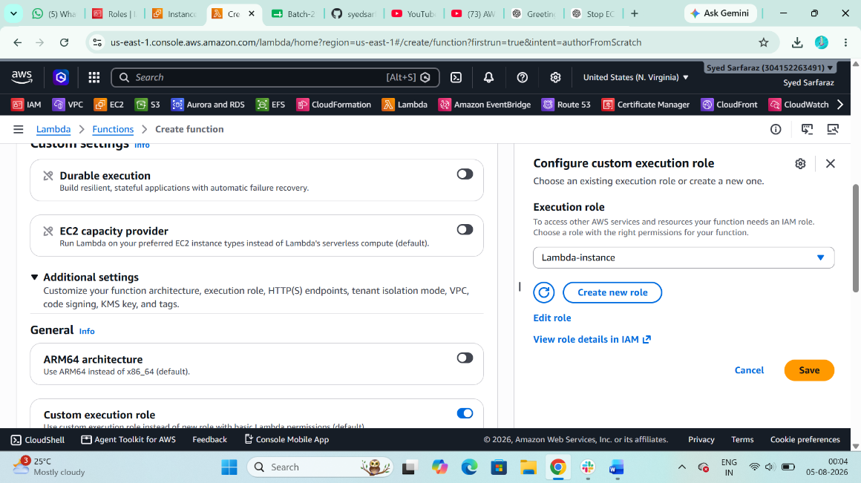

Step 4: Then create a new function
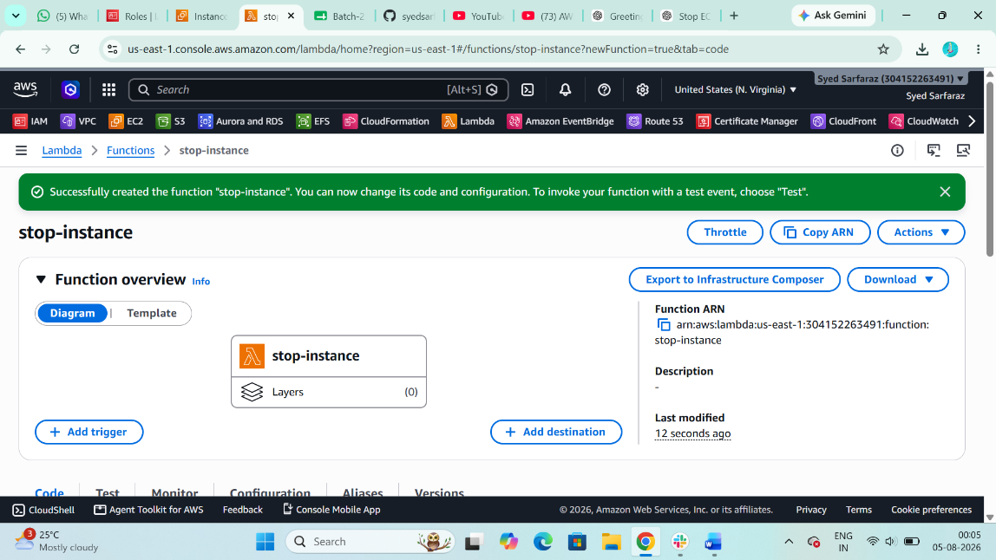

Step 5: Now create a 1 new Instance that you want to stop it Automatically at a Specific Time Using AWS Lambda and EventBridge
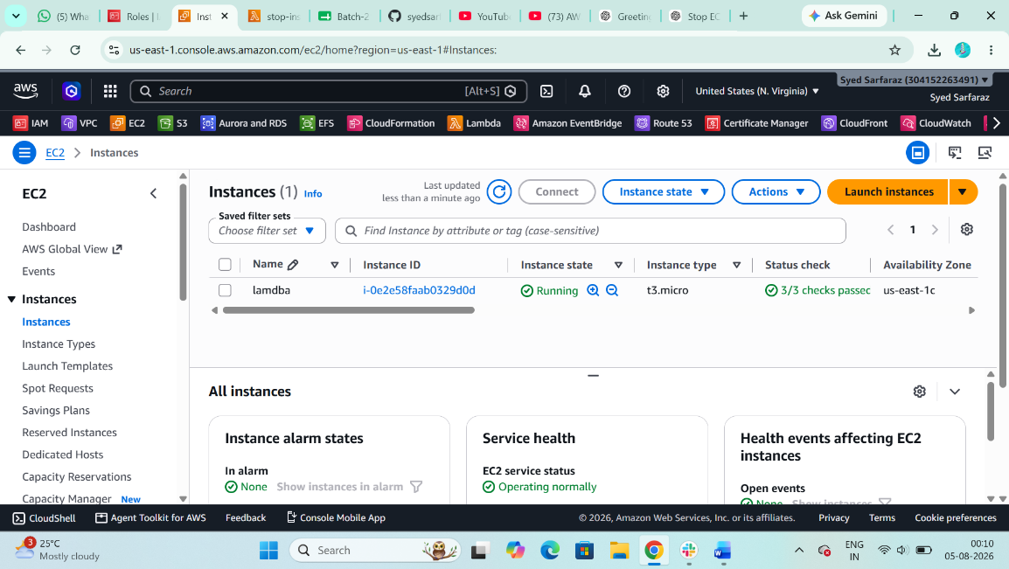

Step 6: Then copy the Instance ID that you want to stop it
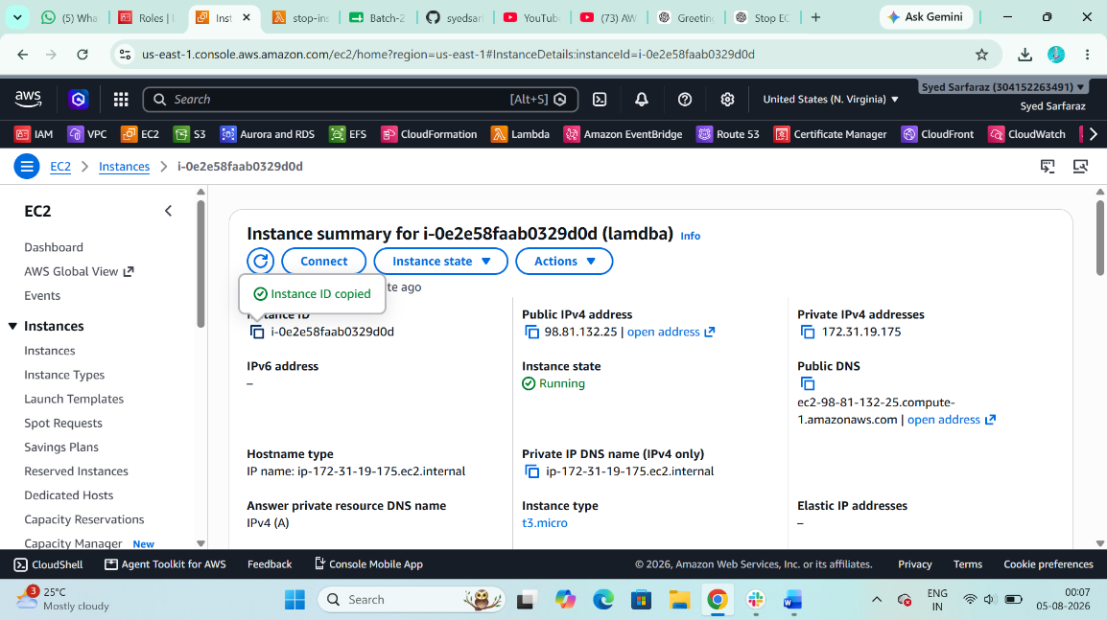

Step 7: Now I am using Python Script to stop the server
EX: Python Script, Replace your Instance id, Region and Your Action
import boto3
region = 'us-east-1'
instance = ['i-xxxxxxxxxxxxxxxxx']
ec2 = boto3.client('ec2', region_name=region)
def lambda_handler(event, context):
ec2.stop_instances(InstanceIds=instance)
print('Stopped your instance: ' + str(instance))
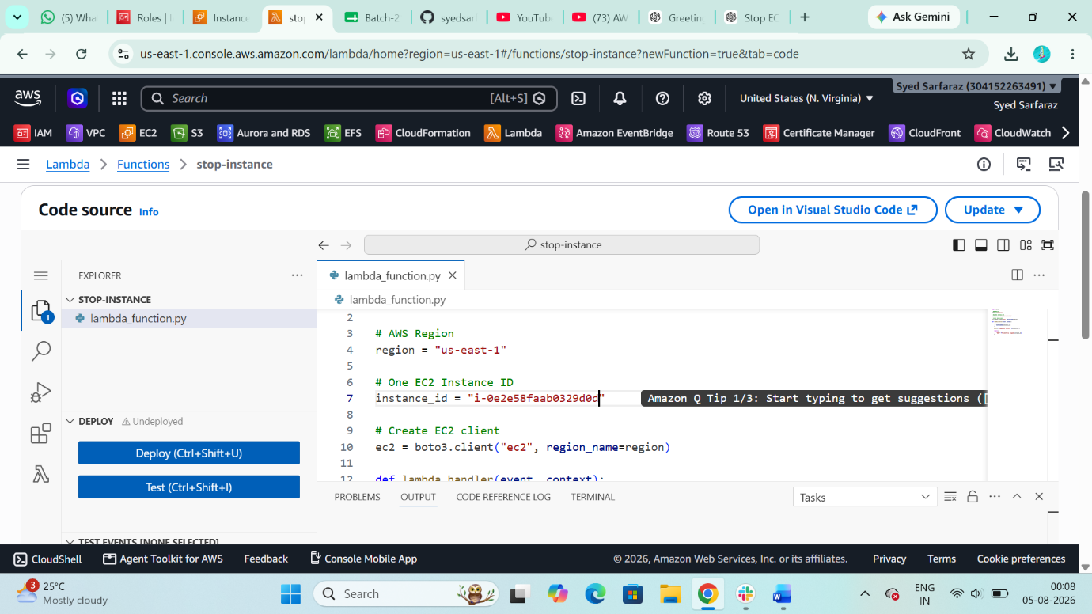

Step 8: Now create a Test Event to stop the server with the help of Python script
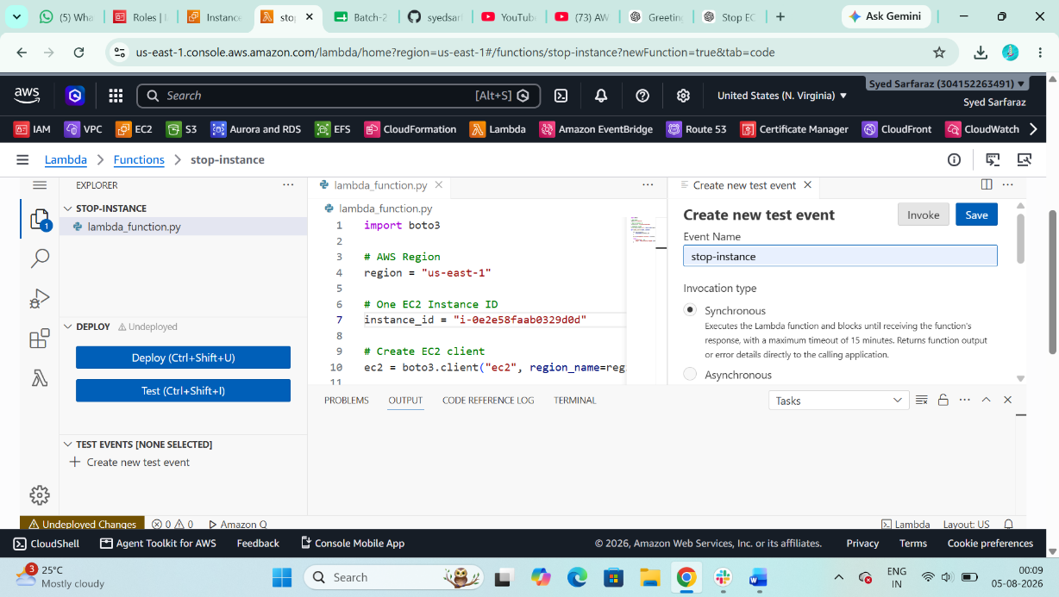
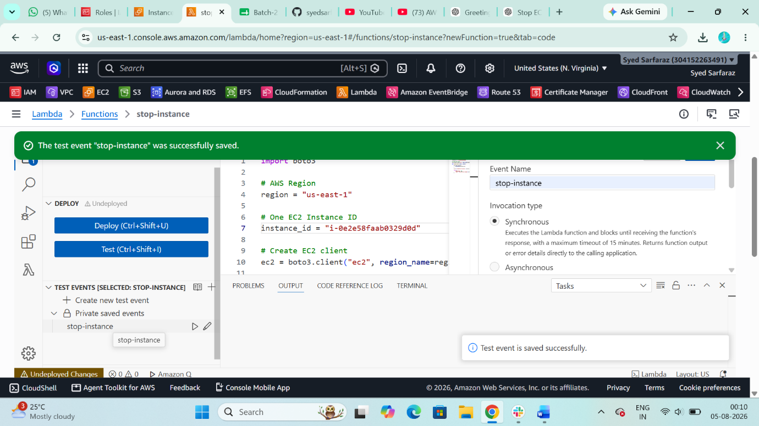

Step 9: After Creating the Test Event, Then Test the Test Event, It will stop the server, But this the manual work now we have to configure the Event to Bridge to Automate the work
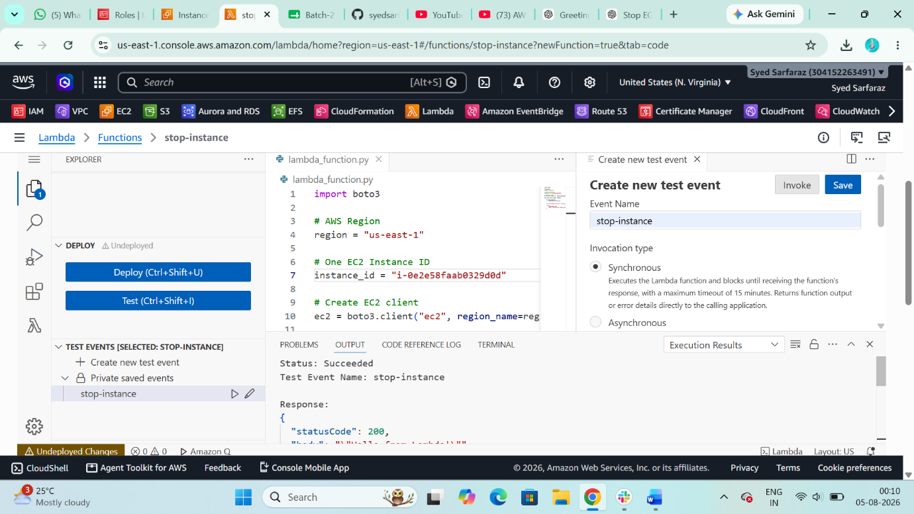

Step 10: Open Amazon Event Bridge then select Eventbridge Schedule
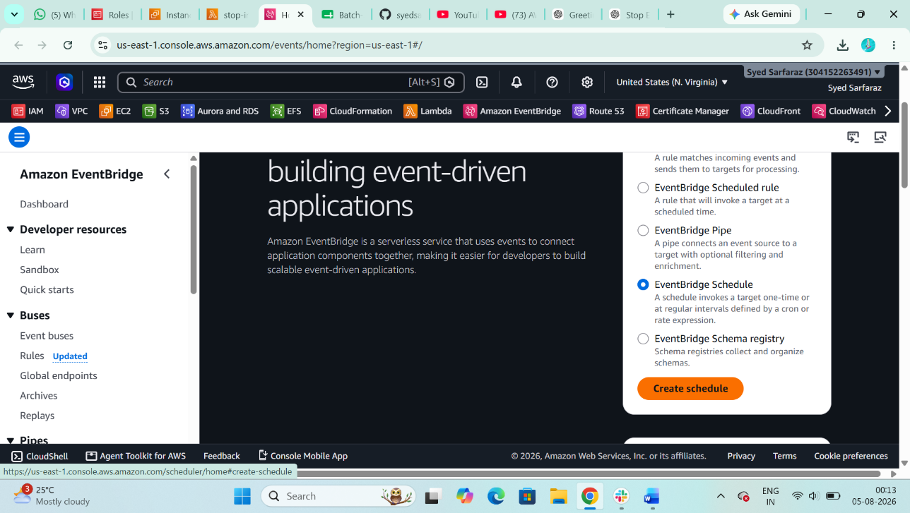

Step 11: Give a Schedule Name
Ex: Stop-server
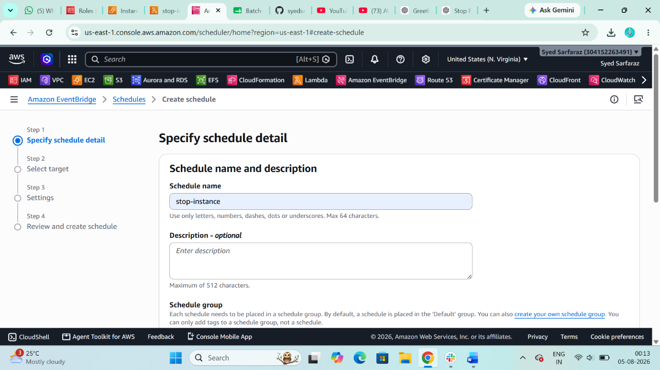

Step 11: Select Templated Targets
Select: Aws Lambda
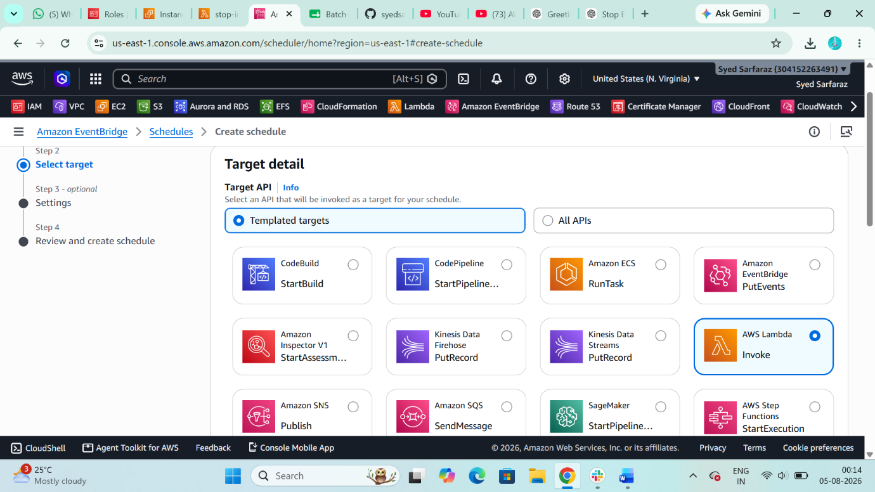

Step 12: Select Schedule pattern
1: In my case I am selecting the One-time schedule
2: Add Date and Time
3: select Flexible time Window
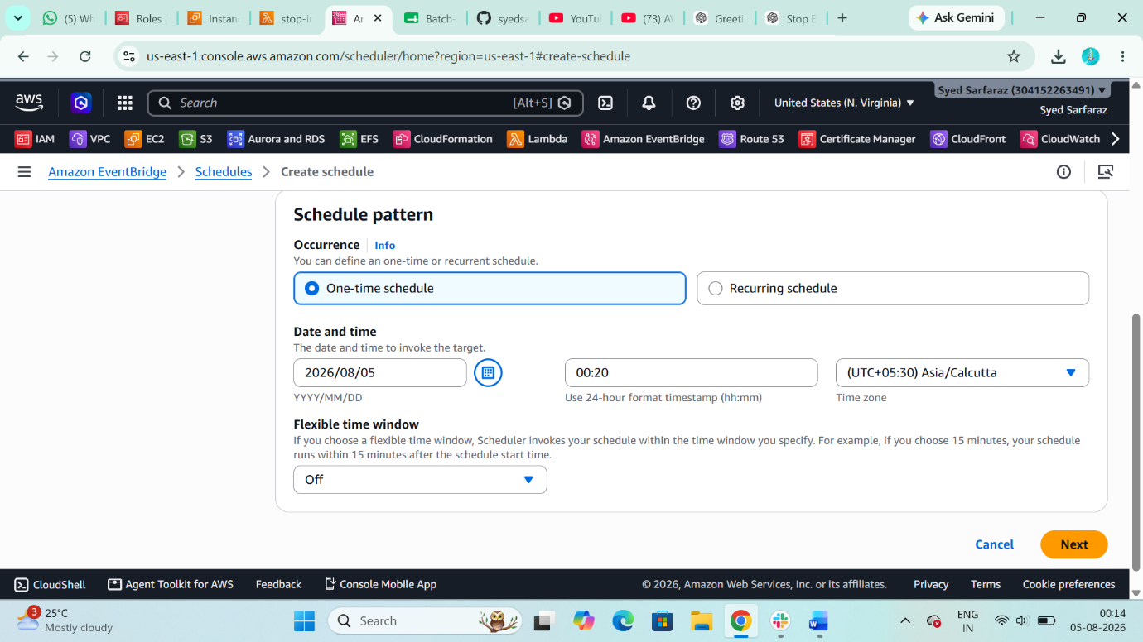

Step 13: select Lambda Function in Invoke section
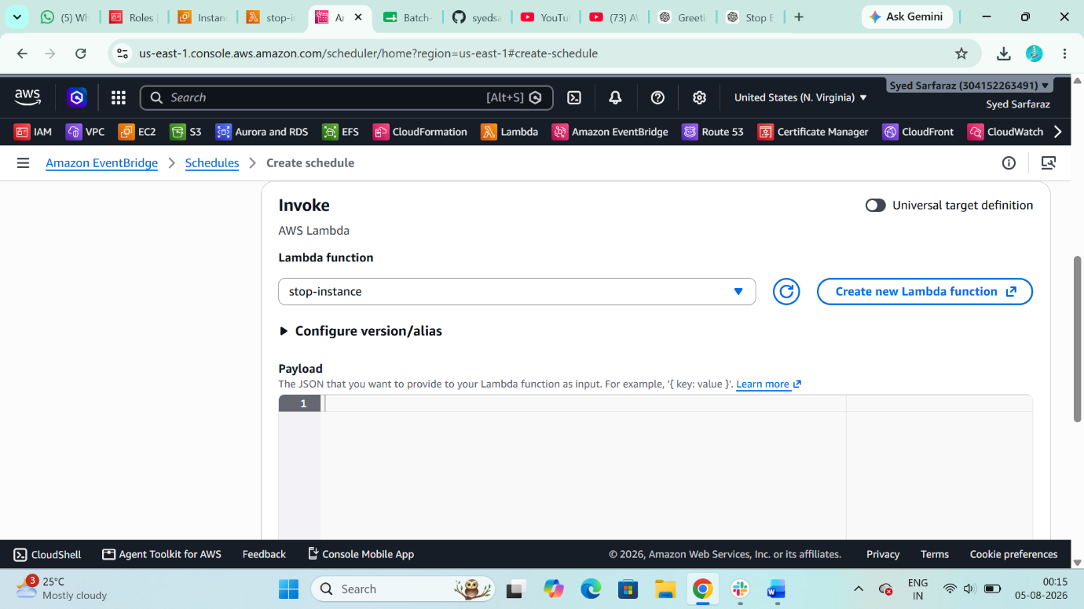

Step 13: Then create it
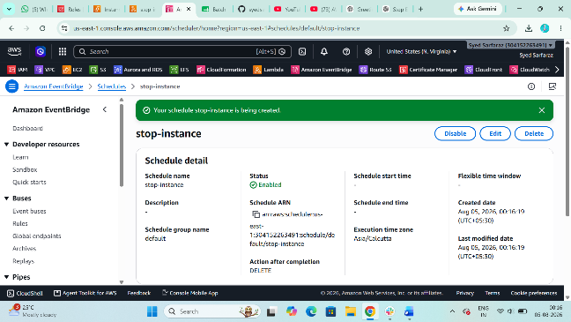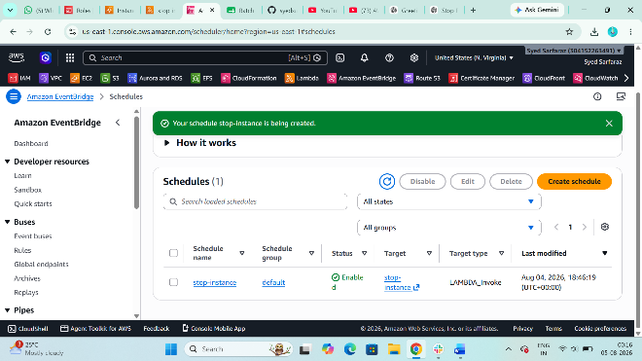

Step 14: Now The server will Automatically Stop at a Specific Time
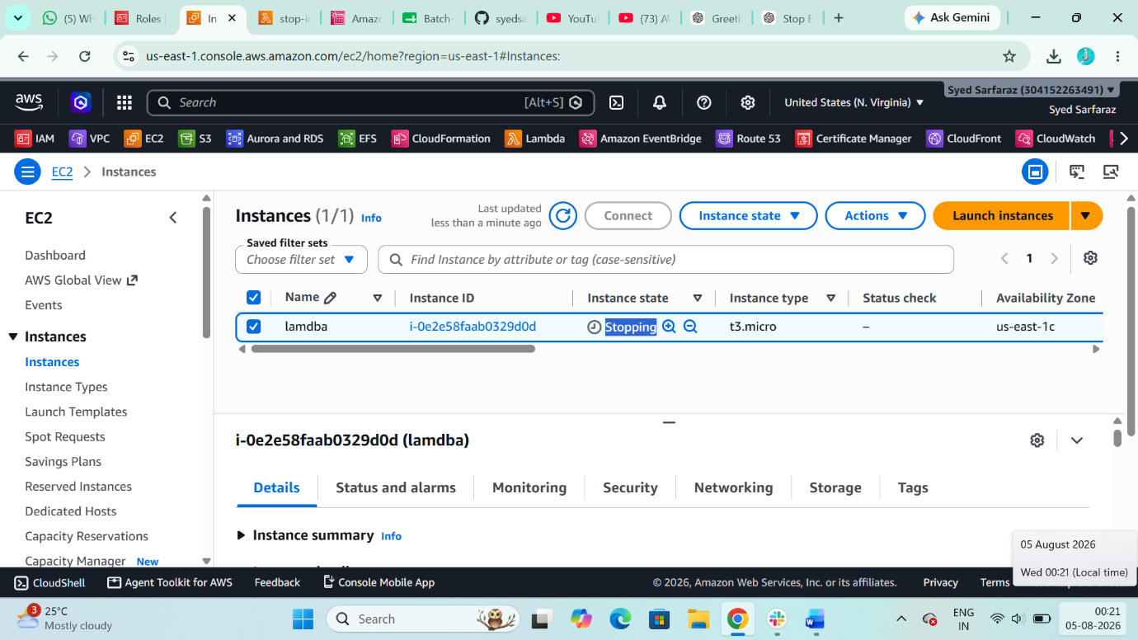
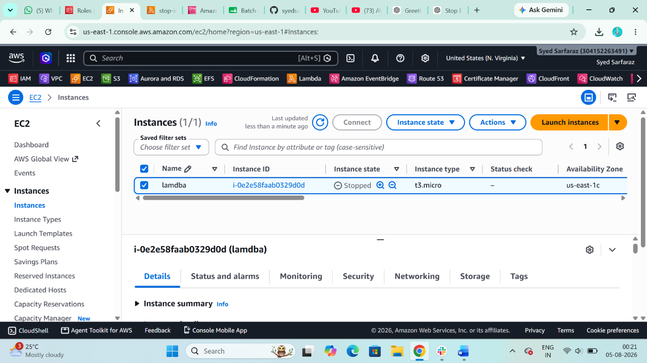

Work Flow of this Task
EventBridge → Lambda → Ec2-Server

